**A Post Detail Report**

**Of**

**International Expert Talk**

**On**

**“Sentimental Analysis in Intelligent Information Systems”**

**July 12, 2021**

**Coordinated by**

**Dr. Garima Mathur**

**&**

**Dr. Payal Bansal**

Organized by



**Department of Electronics and Communication Engineering**

**Poornima College of Engineering**

**Jaipur, Rajasthan- (India)**

**Session Flyer:-**

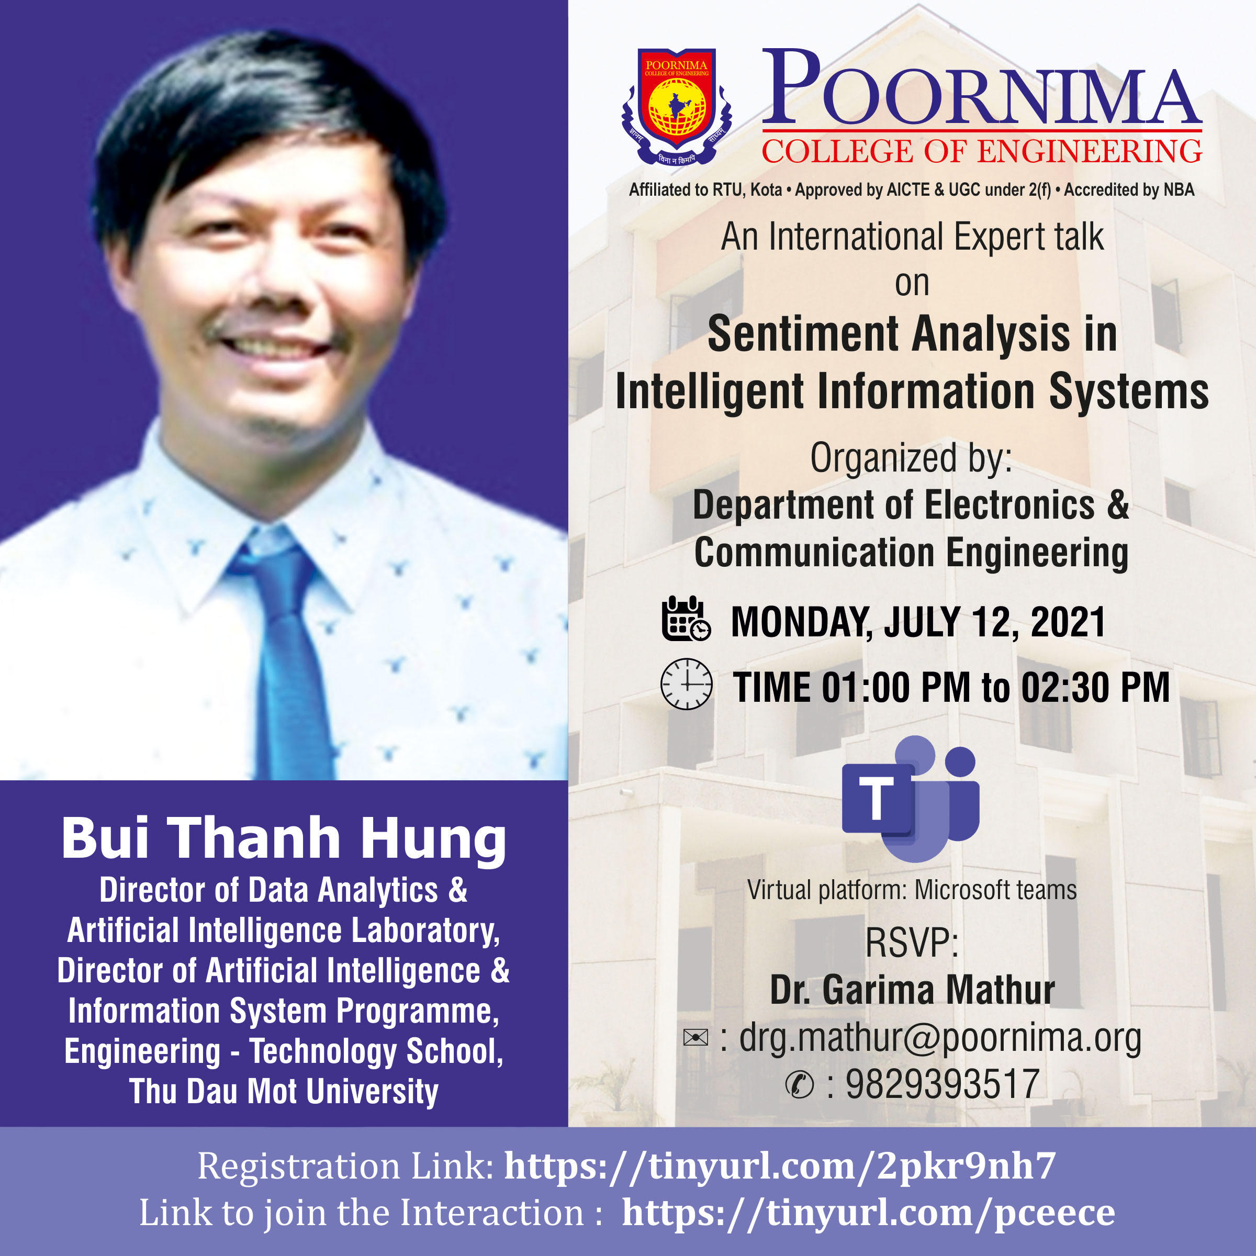

**Session Poster Used:-**

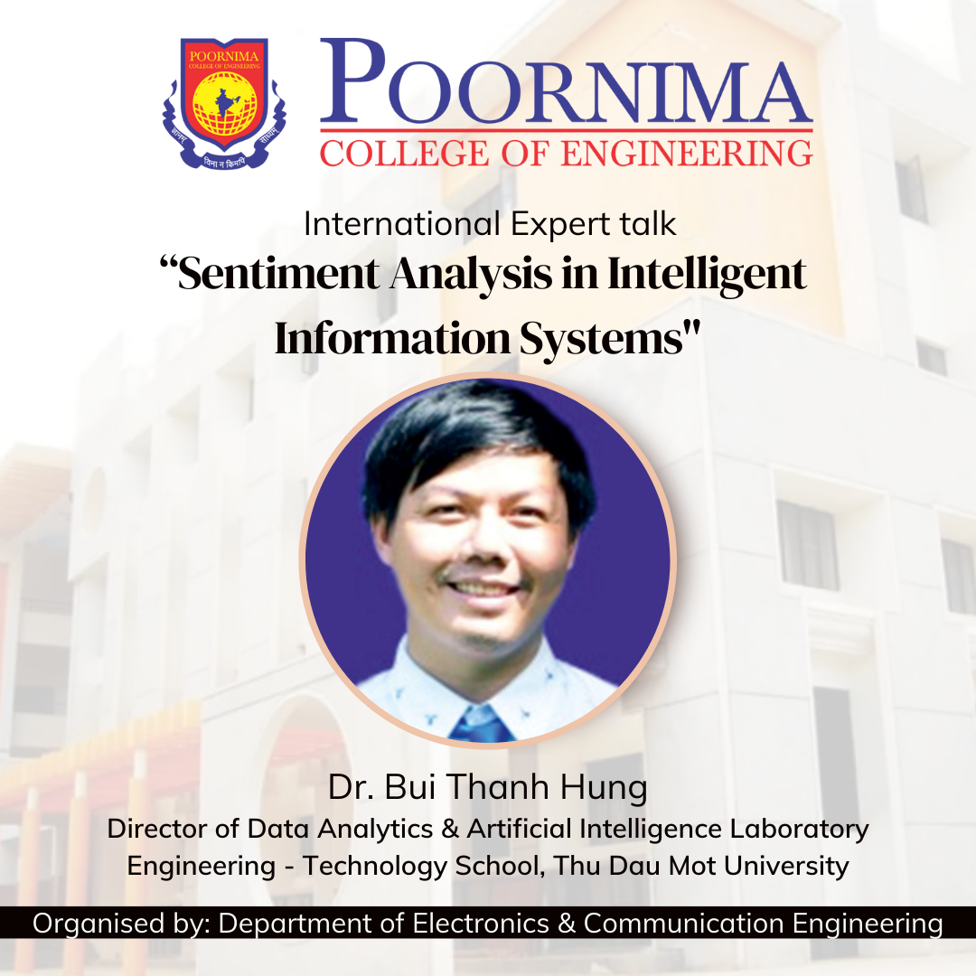

**Speaker’s Profile:-**

He received his M.S. degree and Ph.D. degree from Japan Advanced Institute of Science and Technology (JAIST) in 2010 and in 2013.

He is currently the Director of Data Analytics & Artificial Intelligence Laboratory, Director of Artificial Intelligence & Information System Programme, Engineering - Technology School, Thu Dau Mot University.

He has completed 2 projects, publiced 8 journals, 11 book chapters, 25 International conference papers and 15 domestic conference papers.

He had three best paper awards of FICTA 2018, RICE 2020 and ICAIAA 2021 and is selected as Excellent Scientific Researcher of Thu Dau Mot University in 2019, 2020, 2021. He is a reviewer of many journals and conferences.

He is also a keynote speaker of many domestic conferences of Sai Gon University; Thu Dau Mot university; Industrial University of Ho Chi Minh city; Nguyen Tat Thanh University; International University - VNU, Vietnam as well as of foreign conferences of North Orissa University-India; SIRT India; Indore Institute of Science and Technology- India; VNS Group of Institutions-India; Manipal University- India; Japan-Bangladesh Robotics and Advanced Technology Research Center (JBRATRC), Japan; ITM (SLS) Baroda University, India; SRM Institute of Science and Technology, India; Biju Patnaik University of Technology, Bhubaneswar and Orissa, India and Mandsaur University, India.

His main research interests are Natural Language Processing, Machine Learning, Machine Translation, Text Processing, Data Analytics, Computer Vision and Artificial Intelligence.

**Session Schedule:-**

International Expert Talk Session on ‘Sentimental Analysis in Intelligent Information Systems’ witnessed by the presence of Dr. Mahesh M. Bundele, Director & Principal, Poornima College of Engineering, Jaipur; Dr. Garima Mathur, Head & Professor, Department of Electronics & Communication Engineering, Poornima College of Engineering, Jaipur; Dr. Payal Bansal, Associate Professor, Department of Electronics & Communication Engineering, Poornima College of Engineering, Jaipur.

Dr. Garima Mathur addressed the participants about the International Expert Talk & Its area of learning and its content. In welcome address Dr. Mahesh M. Bundele, director, PCE, update the participants about the benefits & techniques related to Sentimental Analysis, Data Analytics, & Data Science. In last the inaugural session concluded by vote of thanks delivered by Dr. Garima Mathur.

**Glimpses of the Session:-**

